A000-EUR-Viking- Urnes style-Silver-1200 CE

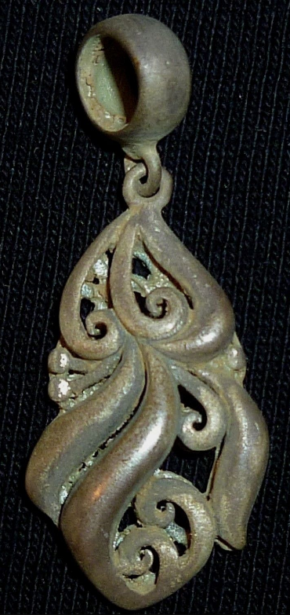 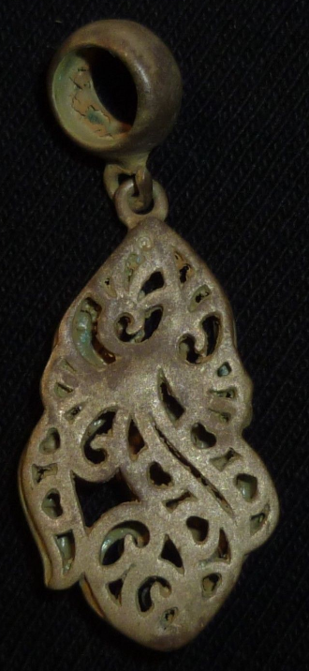 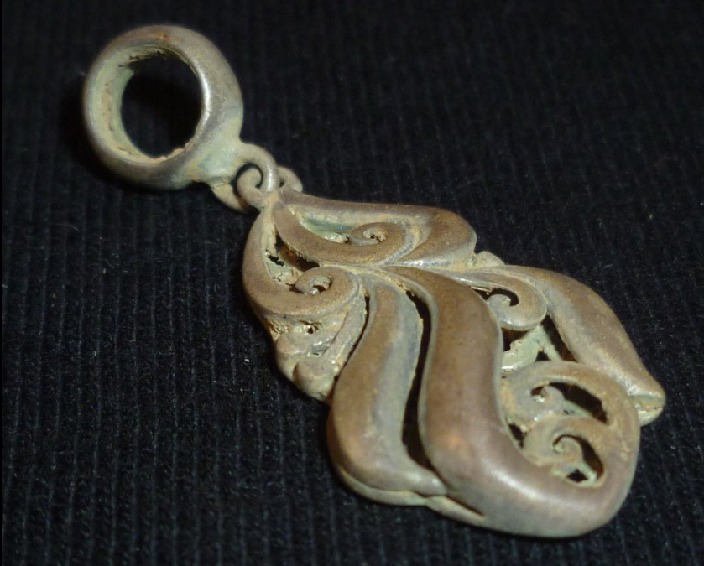

**Case No.: 4**

**Accession No.**

**Formal Label:**

**Display Description:**

The Urnes, a.k.a. runic style, from late XI to early XII centuries, is the latest and probably the best known of the Viking styles. Unlike the rich in detail Ringerike style, the Urnes ornaments are quite laconic. Most often they comprise  snakes or dragons, with elegant heads of complex shapes, sometimes with one ot two paws, as well as four-legged, long-necked animals with tails. These animals keep the characteristic Viking-style features: the spiral hip of Jellinge origin and the pointed eye of the Ringerike style. Their bodies make up an interlaced pattern with round loops, combining thick and thin lines for beautiful contrast. The snake bodies can be filled with runic inscriptions. The most famous example of this style is a carving from a stave church in Urnes with a four-legged animal caught in the loops of four snakes. Some scholars interpret this as a picture of Ragnarök, others see an allegoric picture of battle between Christianity (the lion) and paganism (snakes).  
  
Source: <https://armstreet.com/news/the-viking-ornaments-six-major-styles>

**Accession Number:**

**LC Classification:**

**Date or Time Horizon:**

**Geographical Area:**

**Map:**

**GPS coordinates:**

**Cultural Affiliation:**

**Media:**

**Dimensions:** H 33.5 mm,W 13.6 mm

**Weight: 2.8 gm**

**Condition:**

**Provenance:**

**Discussion:**

**References:**

**HEIGHT:     33.5  millimeters**

**WIDTH:    13.6  millimeters**

**MATERIAL:  SILVER**

**WEIGHT:    2.8  grams**

**CONDITION:    FINE**